**ODIN II**

**USER GUIDE**



TEAM 11

TODD TOWNSEND, ABRAM FOUTS, KARLA BARRAZA LOPEZ, WENHAO CHENG, XUENING JIA

Sponsor: Brad Smith - Intel Corporation

Advisor: Fu Li

**Table of Contents**

**1 Install Unity**3

Creating a Unity Account 7

1.1 Hardware and Asset Setup 11

1.1.1 Head Mounted Display Setup - VIVE Pro Eye 11

Pick A Room 11

Pick a room with some free space to move around. 11

2. Pick a spot for your base stations 12

3. Set up base stations 13

4. Power and adjust base stations 14

5. Install Link Box 15

6. Install Headset 16

7. Get your Headset Situated 17

8. Install Steam and SteamVR 18

9. Turn on Controllers 19

10. Room Setup and Tutorial 20

Enjoy VR! 21

1.1.2 Import SteamVR Asset into Unity Plugin 22

1.1.3 Calibrate for your eyes 22

1.1.5 Import the Tobii XR SDK 23

1.1.6 Add the TobiiXR Initializer prefab to your scene 23

1.1.7 Configure the Tobii XR SDK 23

1.1.8 Create a cube and place it somewhere in the scene 25

1.1.9 Add the HighlightAtGaze script to the cube 26

1.1.10 Run the scene 27

1.1.11 Insert Custom Scripts Scripts 27

1.1.12 How to access controller information (GUI) 27

1.1.13 How to add cameras for both eyes 30

2 Hardware 32

2.1 Hardware Description 32

2.1.1 Head Mounted Display 33

2.1.2 Host Requirements 33

# **1** **Install Unity**

1. **Go to** [**Unity’s Download Page**](https://store.unity.com/download) **and click “Download Installer for Windows”. A UnityDownloadAssistant-x.x.exe file should be downloaded to your “Downloads” folder (where x.x is the current Unity version).  
   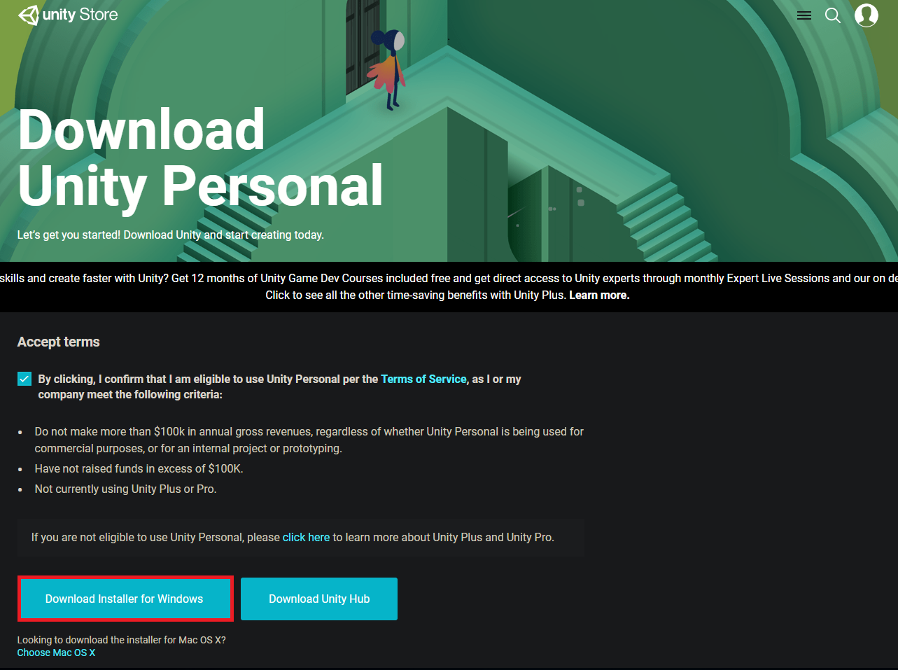**
2. **Open the downloaded installer. You will see a screen like this:  
   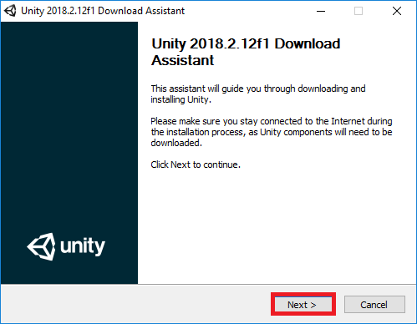**
3. **Accept the license and terms and click Next.  
   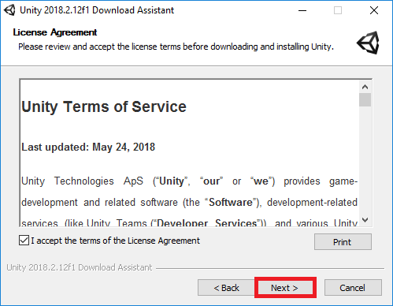**
4. **Select the components you would like to be installed with Unity and click “Next”. Note: If you ever want to change the components, you can re-run the installer.  
   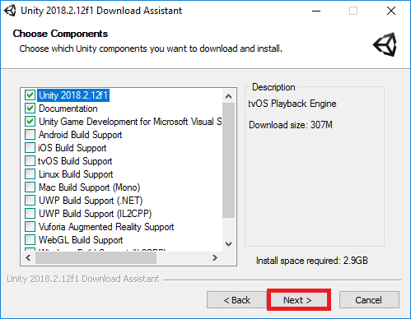**
5. **You can change where you want Unity installed, or leave the default option and click “Next”.  
   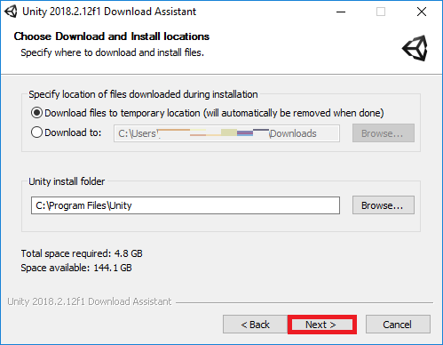**
6. **Depending on the components you selected, you may see additional prompts before installing. Follow the prompts and click “Install”. Installing Unity may take some time. After the installation is finished, Unity will be installed on your computer.**

## 

## 

## 

## 

## 

## Creating a Unity Account

1. **Unity requires an account for use. Start by opening Unity which can be done through the Desktop or Start Menu shortcuts.  
   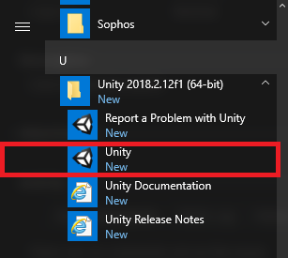**
2. **If you have a Unity account already, you can sign in here and skip the rest of this guide. If you do not have a Unity account, click “create one”.  
   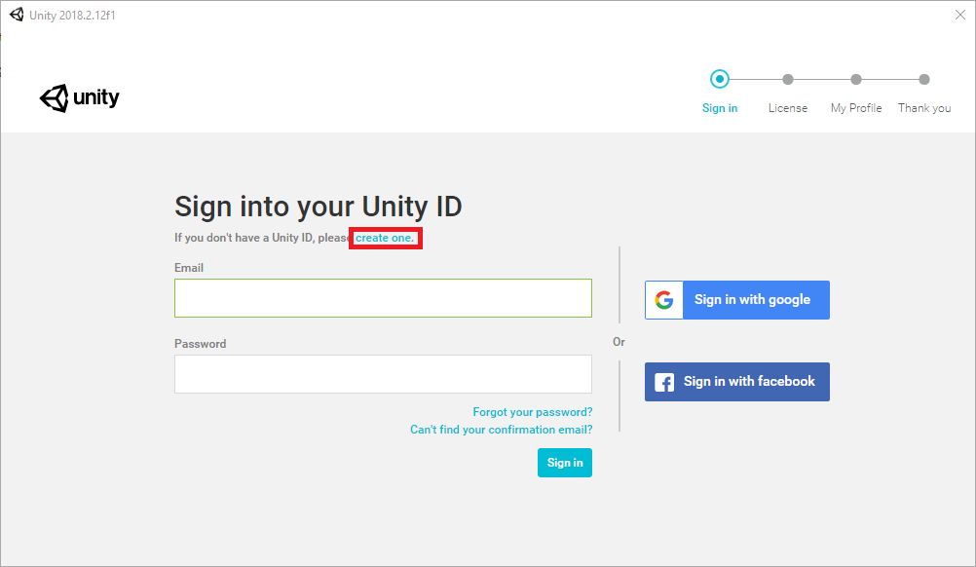**
3. **Fill in the forms to create your Unity account. Then click “Create a Unity ID”. Alternatively, you have the option of signing up with a Google or Facebook account.  
   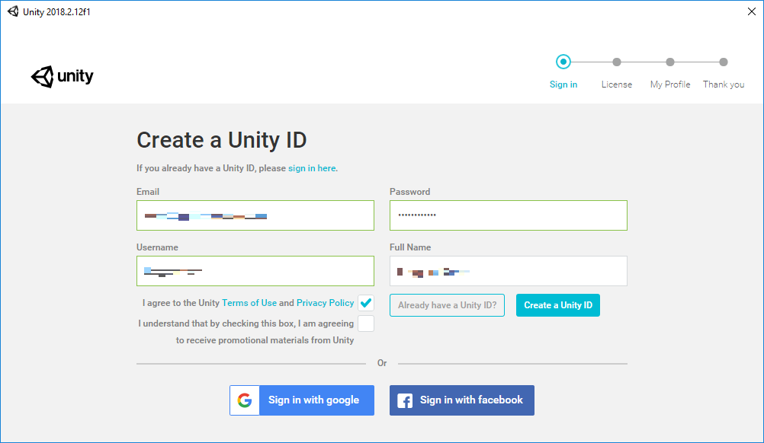**
4. **You will receive a confirmation email sent to the email used to signup for a Unity ID. Click “Link to confirm email” to confirm your email.  
   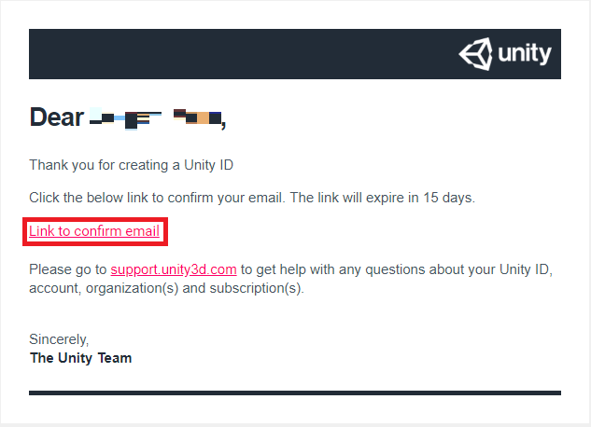**
5. **Go back to the Unity application and click “Continue” after confirming your email.  
   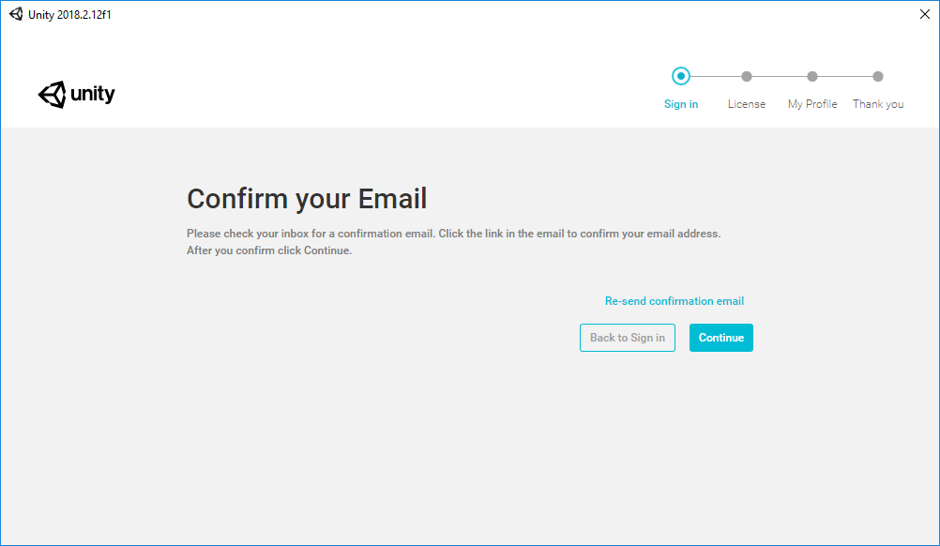**
6. **Select “Unity Personal” and click “Next”.  
   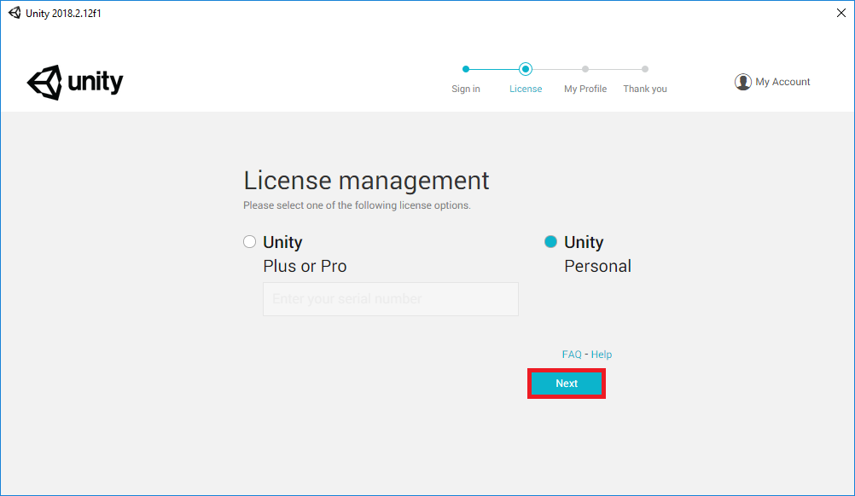  
   You are now setup to create games using Unity 3D Personal Edition.**

## **1.1** **Hardware and Asset Setup**

### **1.1.1** **Head Mounted Display Setup - VIVE Pro Eye**

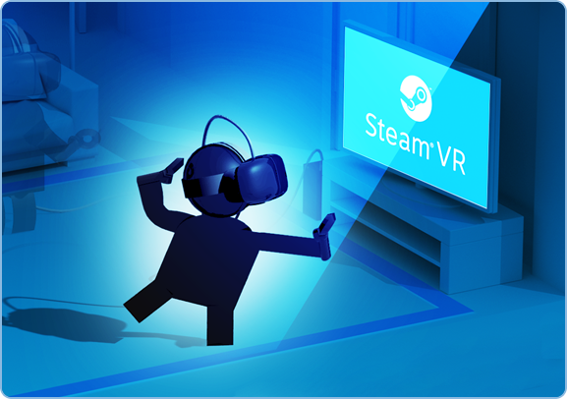

## **Pick A Room**

## Pick a room with some free space to move around.

* For Room Scale VR you'll need at least 2m x 1.5m (6.5ft x 5ft). The maximum supported distance between base stations is 5m (16ft).
* Make sure you have some room overhead, as some experiences may have you reaching above your head.
* Your VR area should be clear of furniture and pets.

Note: The HTC Vive and SteamVR supports Room Scale, Standing, and Seated VR experiences.

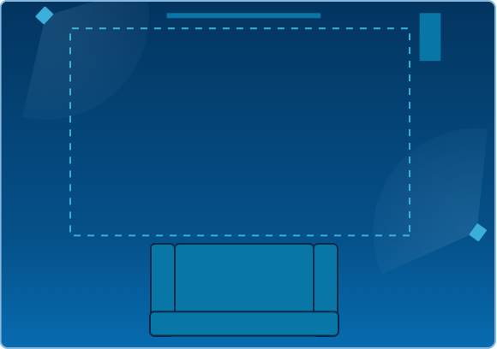

## **2. Pick a spot for your base stations**

Pick two corners of the room opposite of each other that have a good view of your chosen VR area.

* Your bases don't have to be on the edges of your chosen play area, as long as they can see each other, and aren't more than 5 meters (16.5 feet) apart.
* Your area doesn't have to be a perfect square.
* Your bases will each need access to a power outlet.

**More Room Examples**

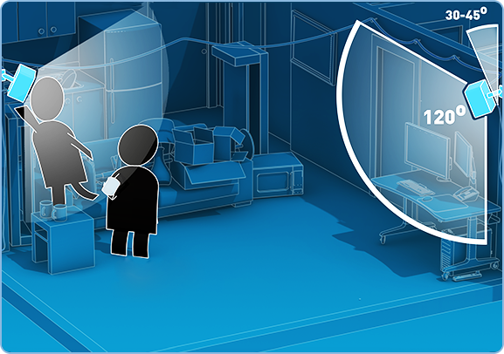

## **3. Set up base stations**

Base stations should be:

* Above head height (ideally over 2m or 6.5 ft)
* Angled down around 30-45°
* Have an unobstructed view of each other

You can use the included mounts to install your base stations, but tripods, light stands, cargo poles, or high bookcases are also viable set up options.

**Mounting Options**

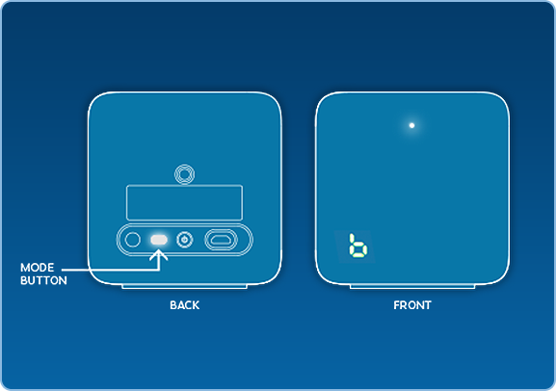

## **4. Power and adjust base stations**

Plug your base stations into an outlet with the provided power cords. Then check the front panel of each base and make sure one is in mode "b" and one is in mode "c":

* If your bases are not in the proper modes, press the mode button on the back of each base station to change modes.
* It doesn't matter which base is in which mode
* Look at the base stations LEDs and make sure they are solid green.

**Base Station Troubleshooting**

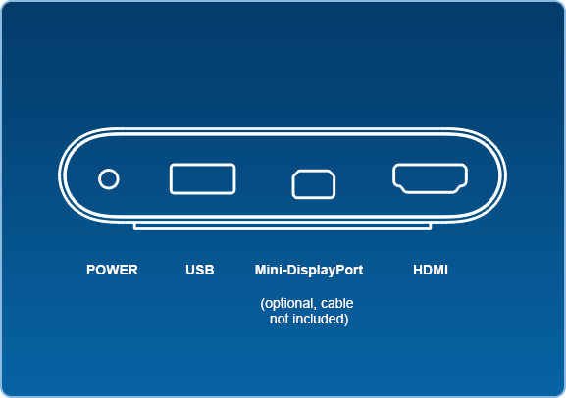

## **5. Install Link Box**

Connect your Link Box to your computer using the side of the Link Box **without** orange ports.

* Use the HDMI cable to connect the Link Box to your computer's graphics card. Use the USB cable to connect the Link Box to an available port on your PC.
* Then plug the power cord into the Link Box, and plug it into a power outlet.
* Once your Link box is connected to your PC, do not unplug it. Drivers will immediately start installing.

**More info**

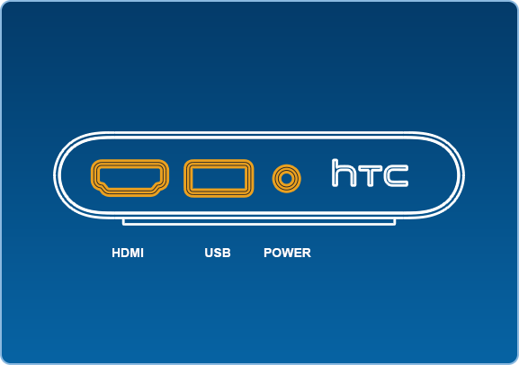

## **6. Install Headset**

Connect your Headset to your Link Box using the side of the Link Box **with** the orange ports.

* The end of your Headset's attached 3-in-1 tether has three orange tipped cords (USB, HDMI, and Power). Plug all three of these into the side of the Link Box with orange ports.
* Your Headset and Link Box should now be connected like the diagram to the left.
* Once your Headset is connected, do not unplug it - important drivers will immediately start installing.

**More Info**

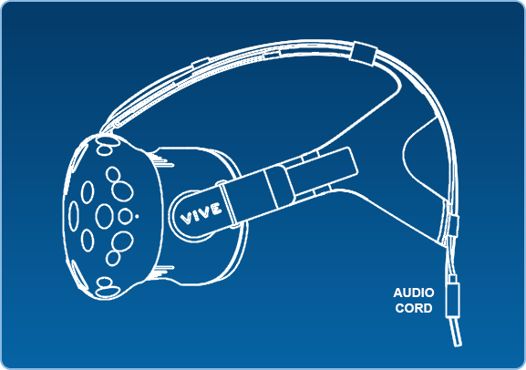

## **7. Get your Headset Situated**

Remove the lens film, proximity sensor film (next to lenses), and camera film – see appendix for lens care.

* There's an audio cable port coming out of the back of the headset. Plug in the included earbuds (or your favorite headphones) here. The Vive PRE headset has a built-in mic, so don't worry about speaking into the earbud's mic.
* When not using your headset, store it with the lenses pointed away from any source of direct sunlight. Failure to do so may cause damage to the headset display.

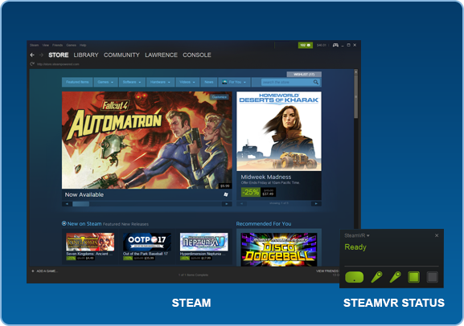

## **8. Install Steam and SteamVR**

Download and install Steam <https://store.steampowered.com/about/> You will need to create an account. Once you've done this, or if you already have Steam, install SteamVR **here**.

Launch SteamVR

* You can do this by clicking the VR button that appears in the top right corner of the Steam client.
* You can also launch SteamVR from the Library under Tools.

The SteamVR Status window will show up. Follow the prompts to finish installing your Vive.

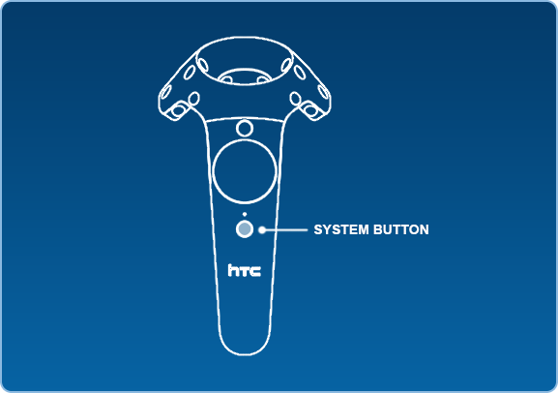

## **9. Turn on Controllers**

Power on your Controllers by pressing the System Button (the button below the trackpad on each controller).

* Don't worry right now about plugging them in - they should come out of the box somewhat charged.
* Your controllers will automatically pair to your Headset when turned on for the first time.

**Troubleshooting**

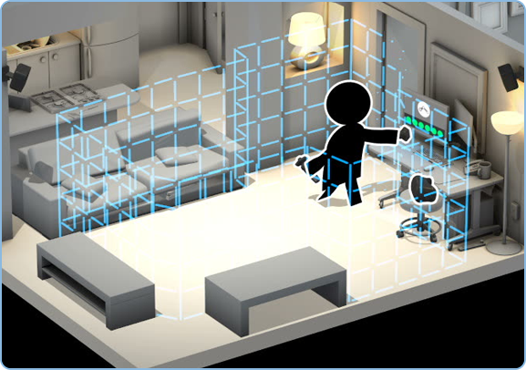

## **10. Room Setup and Tutorial**

Follow the instructions for Room Setup to set up your room. At the end of Room Setup it will launch into a tutorial to teach you about SteamVR, Chaperone, controllers, and the Dashboard.

You can run Room Setup and the Tutorial at any time by clicking on the SteamVR menu and selecting Run Room Setup or Run Tutorial.

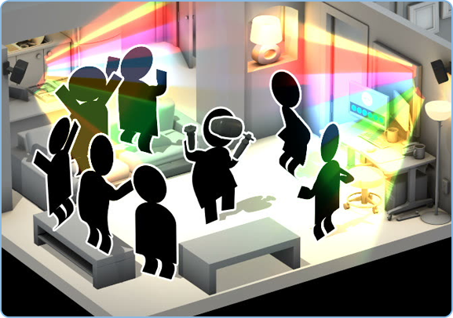

## **Enjoy VR!**

### **1.1.2** **Import SteamVR Asset into Unity Plugin**

* Go to the Unity Asset Store tab in Unity and search “SteamVR” in the search field at the top.
* Download and import the SteamVR Plugin into your project.
* At the end of the import, you may see a prompt that says “API update required.” Click on “I made a backup, go ahead!”
* Another prompt titled “SteamVR_Settings” will give options to “Accept All” or “Ignore All.” Click on “Accept All.”
* Navigate to SteamVR > Prefabs in your Assets folder.
* Click and drag the SteamVR and CameraRig prefabs into your scene.
* Delete the Main Camera from your scene.
* Save the scene and your project. You now have a project ready to develop for the HTC Vive.

### **1.1.3** **Calibrate for your eyes**

The VIVE Pro Eye Setup guide will automatically start the calibration at the end of the setup flow.If you need to re-calibrate or if you switch users, you can always open the calibration tool from the SteamVR dashboard.

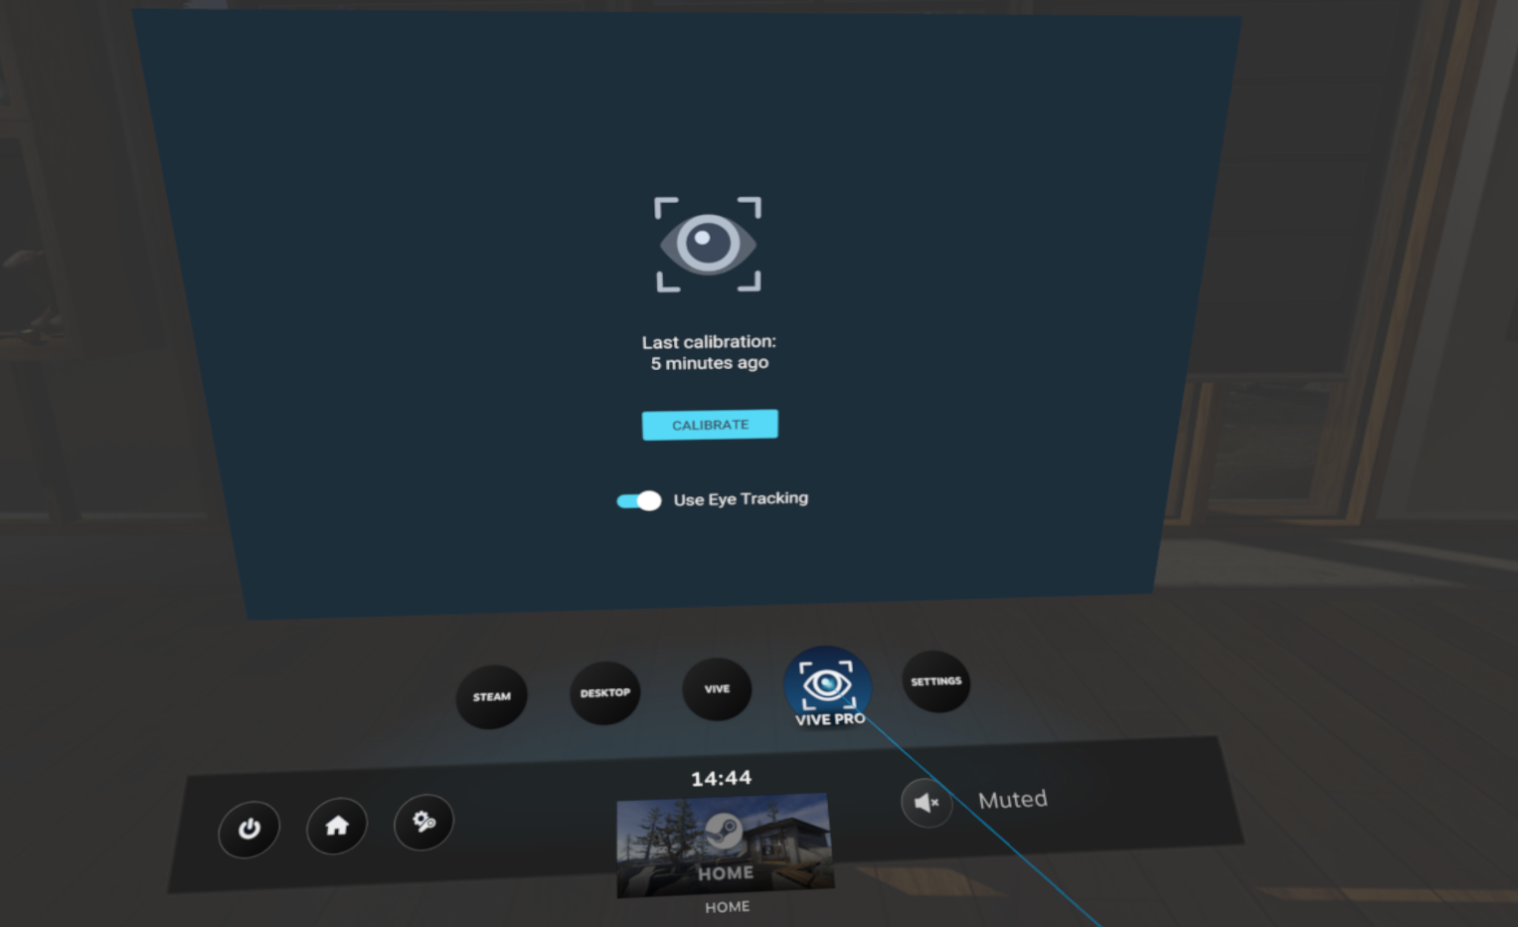

**1.1.4 Download and Import the VIVE SRanipal SDK**

[**Download the VIVE SRanipal SDK**](https://developer.vive.com/resources/knowledgebase/vive-sranipal-sdk/) and import the .unitypackage into your Unity project.

Make sure the VIVE Sranipal SDK works before going to the next step.

The tray icon eyes turn green when eye tracking is active, this should happen when your Unity application is running.

### 1.1.5 Import the Tobii XR SDK

[**Download the Tobii XR SDK for Unity**](https://vr.tobii.com/sdk/downloads/) and import it into your Unity project.

Remember to enable VR support in your Unity project. We support Unity 2018.2.5f1 or later.

If you have an older version of the Tobii XR SDK, remember to remove it before importing the new version to avoid conflicts.

### 1.1.6 Add the TobiiXR Initializer prefab to your scene

The prefab can be found in the Prefabs folder.

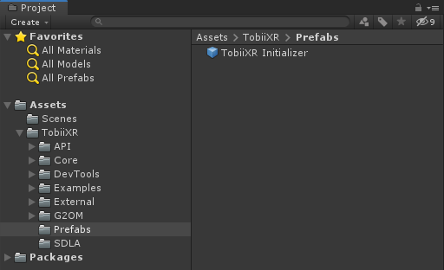

The TobiiXR_Initializer script attached to the prefab calls TobiiXR.Start() to initialize the the Tobii XR SDK.

### 1.1.7 Configure the Tobii XR SDK

**To configure the Tobii XR SDK, edit the fields of the TobiiXR Initializer prefab in your scene.**

1. Make surethe VIVE provider is at the top of the Eye Tracking Providers list.
2. Enable the Support VIVE Pro Eye option.

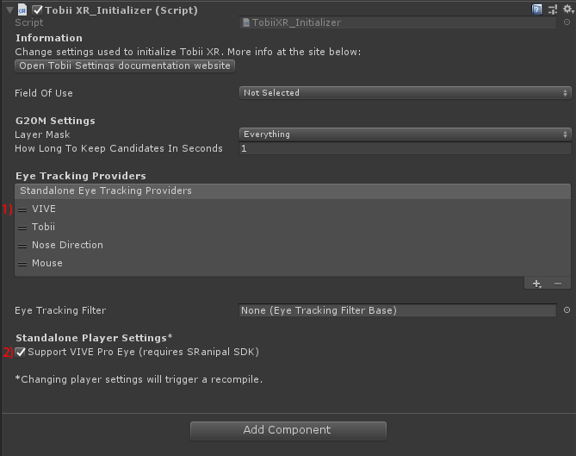

**Read more about the providers and other settings in the** [**Tobii XR Settings**](https://vr.tobii.com/sdk/develop/unity/documentation/tobii-settings/) **page.**

## 

## 

## 

## 

### 1.1.8 Create a cube and place it somewhere in the scene

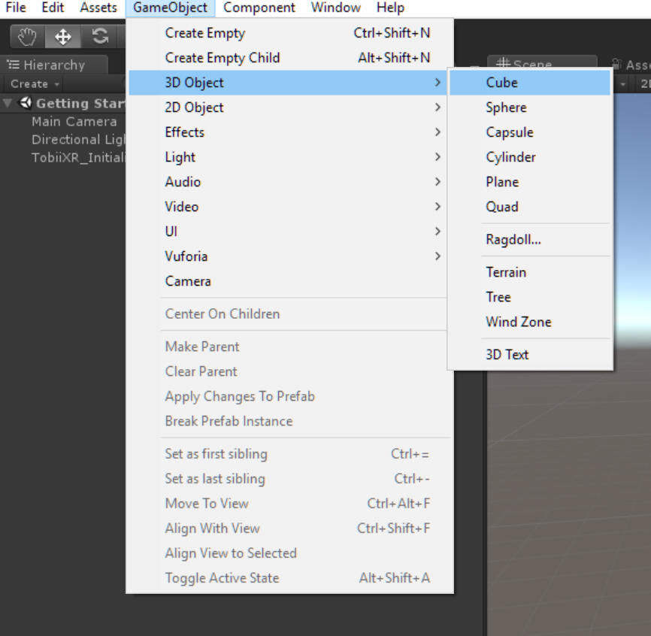

### **1.1.9 Add the HighlightAtGaze script to the cube**

**The `HighlightAtGaze` component implements the `IGazeFocusable` interface, which will be called whenever the object receives or loses focus.**

### 1.1.10 Run the scene

By pressing play, you can now highlight the cube by looking at it.

If you want, you can add more objects that react to gaze to the scene in order to test and play around.

### **1.1.11** **Insert Custom Scripts Scripts**

Unlike most other assets, scripts are usually created within Unity directly. You can create a new script from the Create menu at the top left of the Project panel or by selecting Assets > Create > C# Script from the main menu.

The new script will be created in whichever folder you have selected in the Project panel. The new script file’s name will be selected, prompting you to enter a new name.

### **1.1.12** **How to access controller information (GUI)**

To access the controller input,

1. Be in Unity
2. Turn the controllers on
3. Go to the *Window* drop down menu
4. Select *SteamVR Input View*

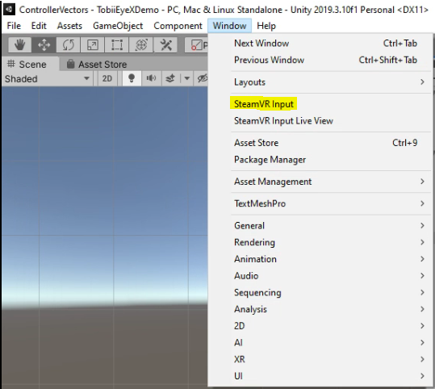

You will be shown a window where you can select default actions, or if you are creating a custom action you can add it by clicking the “+” on the *In* actions box.

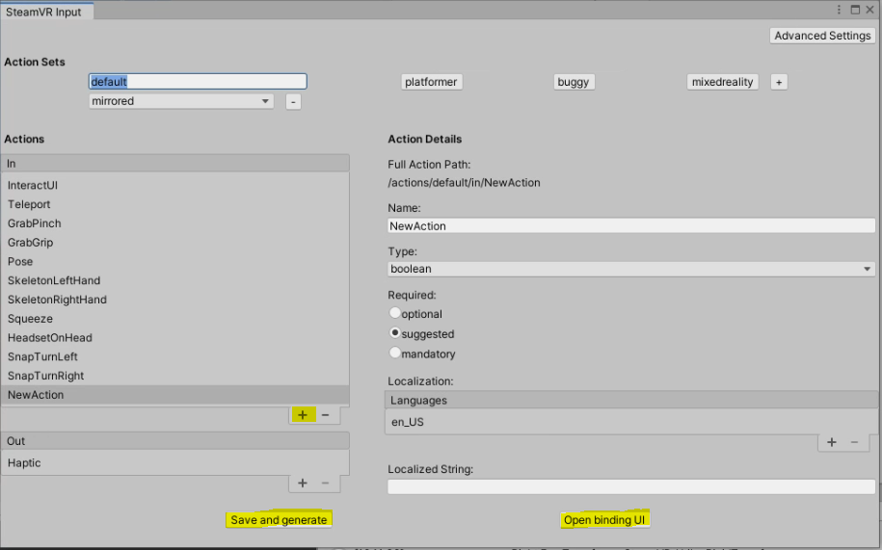

After creating your new action, click “*Save and generate*” to save your changes and to generate c# files. Then click “*Open binding UI*” to apply any new scripts to the buttons on your controller.

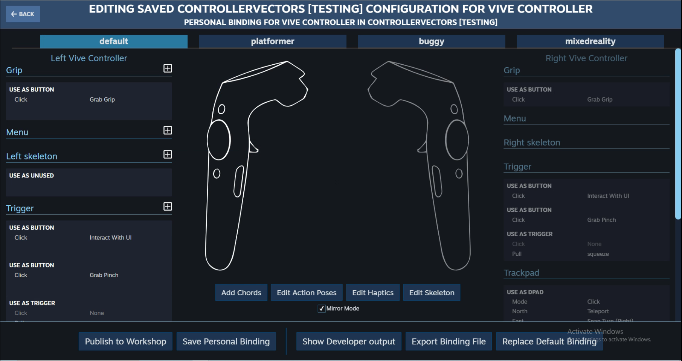

### **1.1.13** **How to add cameras for both eyes**

The following method is adopted to make the left and right eyes display content separately.

1. Drag SteamVR "CameraRig" prefab onto the scene.
2. Create two empty game objects, named CamLeft and CamRight, and set them at the same coordinates.
3. Add a SteamVR_Camera script component to each.
4. In the inspector, on the "SteamVR_Camera" component you just added, click the "Expand" button.
5. Create two new layers: "Left" and "Right"
6. In the inspector, set Target Eye: Left, and untick "Right" in Culling Mask. CamRight in the same way.

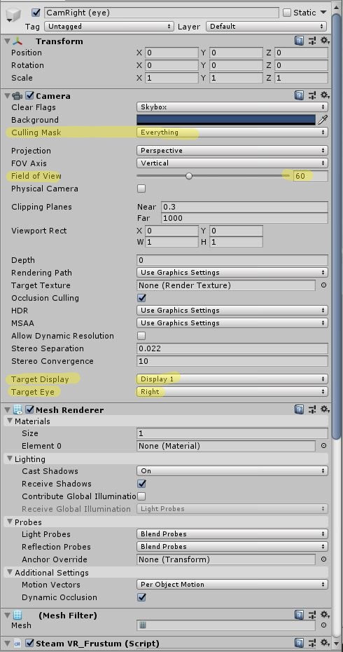

Then import theRotate Frustum script to the left and right eye cameras respectively.

1. Download scripts from <https://github.com/7-TNT/ODIN-II>
2. Drag the script into the left and right camera respectively. Then it will be displayed in the camera's "Inspector" menu.
3. After running the program, we should be able to click the touch controller to translate and rotate every camera.

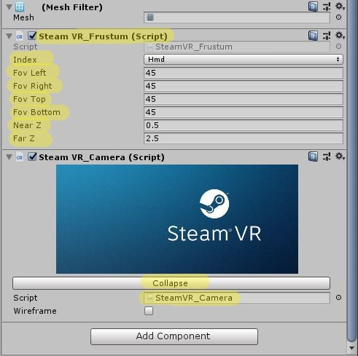

This is a screenshot of setting up in unity：

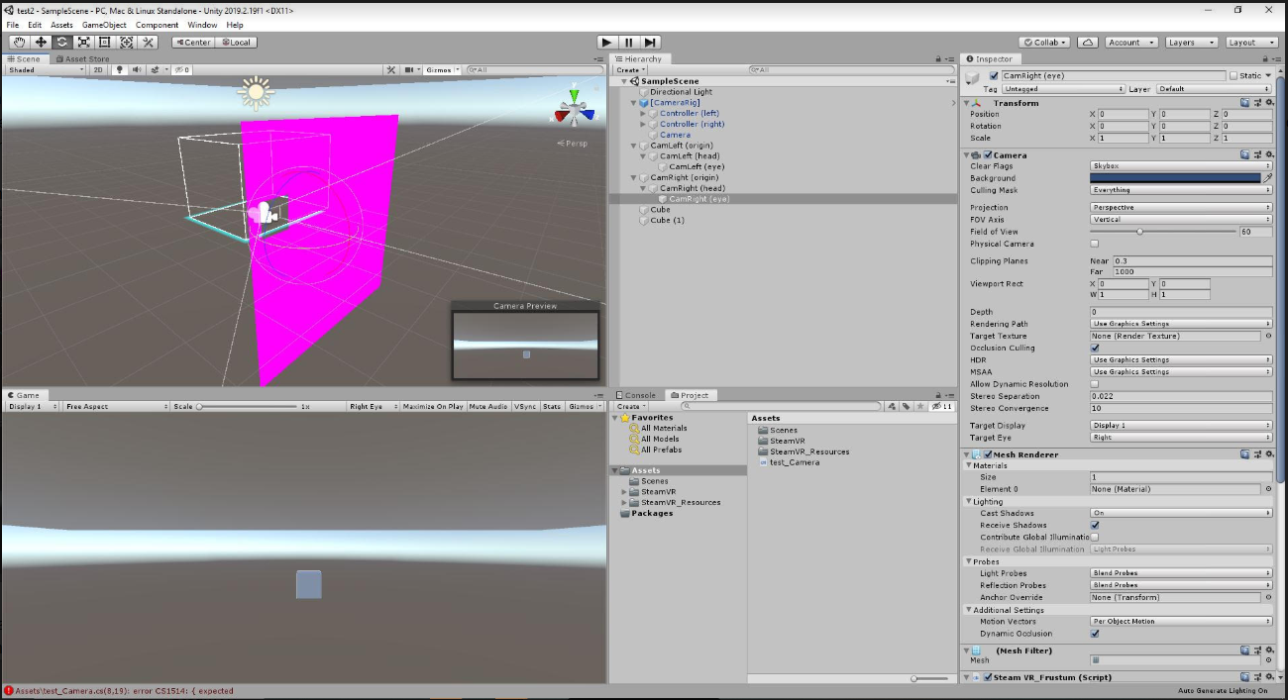

# **2** **Hardware**

**This section describes the hardware needed to fully assemble the ODIN II project.**

## 2.1 Hardware Description

**Figure 1. Block Diagram**

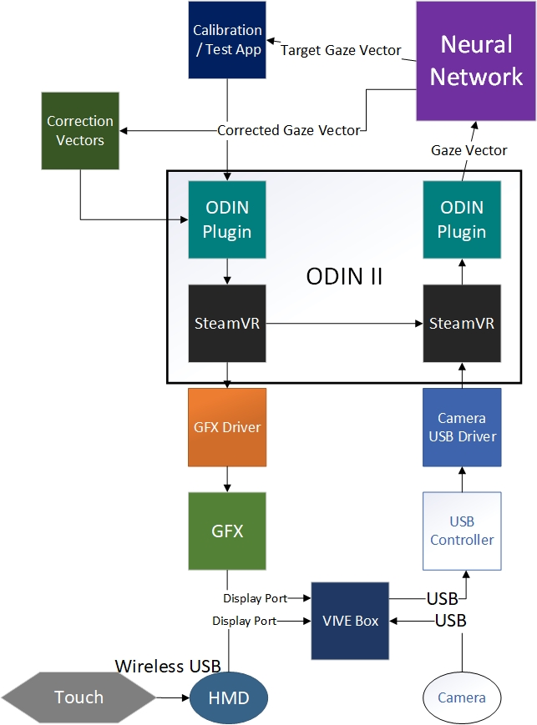

## 2.1.1 Head Mounted Display

**VIVE Pro Eye**

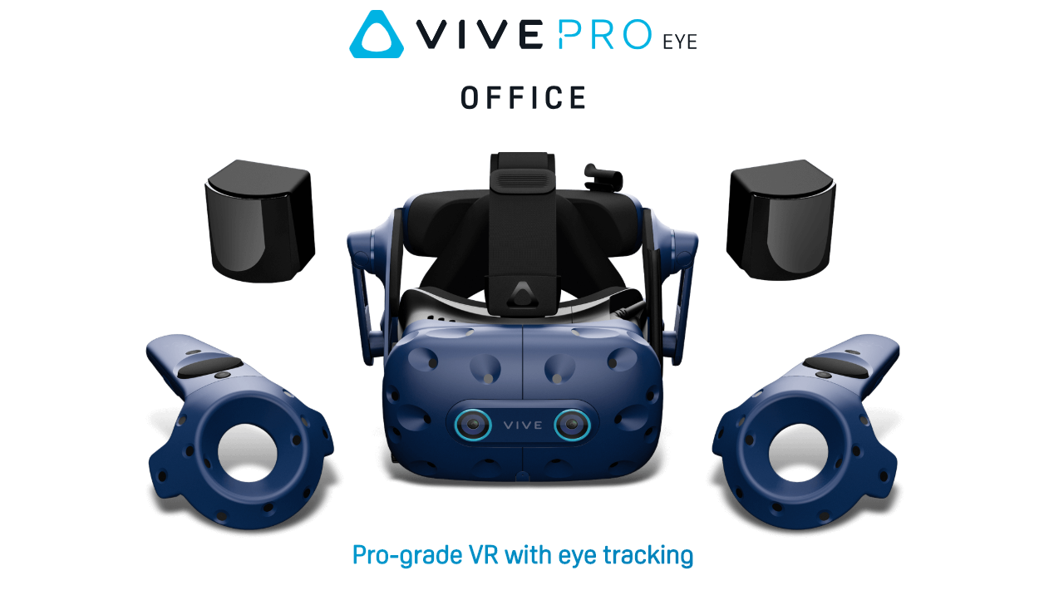

* **HTC Vive Pro Eye**
  + Display: OLED
  + Resolution: 1440 x 1600 pixels per eye
  + Refresh Rate: 90 hz
  + Platform. SteamVR
  + Field of View: 110 °
  + Lens Type: Fresnel
  + Focal Length: 60.8-74.6mm

## **2.1.2** **Host Requirements**

* [**Host Platform**](https://docs.google.com/document/d/1zUPVoFRKUzO7QVVtqewp7nkH0vIYITJF/edit#heading=h.gjdgxs)
  + Processor: Intel Xeon Silver 4208 (8-core Cascade Lake SP)
  + Motherboard: Supermicro X11SPL-F
  + Architecture: x86_64
  + Graphics: EVGA GT1030 (stock) and Radeon 560X
  + SSD: 256GB M.2
  + RAM: 128GB on 8x16GB DIMMs
  + VR System: HTC VIVE Pro Eye
  + Video out: =>DisplayPort 1.2
  + USB ports: =>1x USB 3.0

**Resources**

[**https://cs.hofstra.edu/docs/pages/guides/unity_install.html**](https://cs.hofstra.edu/docs/pages/guides/unity_install.html)

[**https://support.steampowered.com/steamvr/HTC_Vive/**](https://support.steampowered.com/steamvr/HTC_Vive/)

[**https://circuit-dev.825mediatesting.com/vive-steamvr-setup/**](https://circuit-dev.825mediatesting.com/vive-steamvr-setup/)

[**https://docs.unity3d.com/Manual/CreatingAndUsingScripts.html**](https://docs.unity3d.com/Manual/CreatingAndUsingScripts.html)

[**https://vr.tobii.com/sdk/develop/unity/getting-started/vive-pro-eye/#step-6-configure-the-tobii-xr-sdk**](https://vr.tobii.com/sdk/develop/unity/getting-started/vive-pro-eye/#step-6-configure-the-tobii-xr-sdk)

[**https://enterprise.vive.com/us/product/vive-pro-eye-office/**](https://enterprise.vive.com/us/product/vive-pro-eye-office/)